SHELL SCRIPT

Table of Contents

Introduction 1

Implementation 1

Vulnerabilities & Security Recommendations 7

Reference List 8

# Introduction

Shell scripting has mostly been known to be an efficient system administration technique in which system administrators can perform automatic administrative tasks by invoking the shell scripts. These are mostly Windows Powershell and Linux Bash scripts facilitating the administration through automatic invocation in the shell's terminal. The bash scripts can also be programmed to perform basic tasks concerning the field of use, as such, this project implements a bash script illustrating basic functions of a system administrator such as listing the contents of the current working directory (Couto and Lamurias, 2018).

# Implementation

The program implements a shell menu listing the options of the main functionalities of the bash script. Option q quits from the system as demonstrated in the project and the code attached.

Listing the contents of the current directory can be essential in the search process in which an admin seeks to find a given file suspected to be the current working directory. Usually, this can simply be achieved through the ls command in the Linux environment (Flynt, et.al 2017), in this project, however, an "echo" command is used to list all as demonstrated.

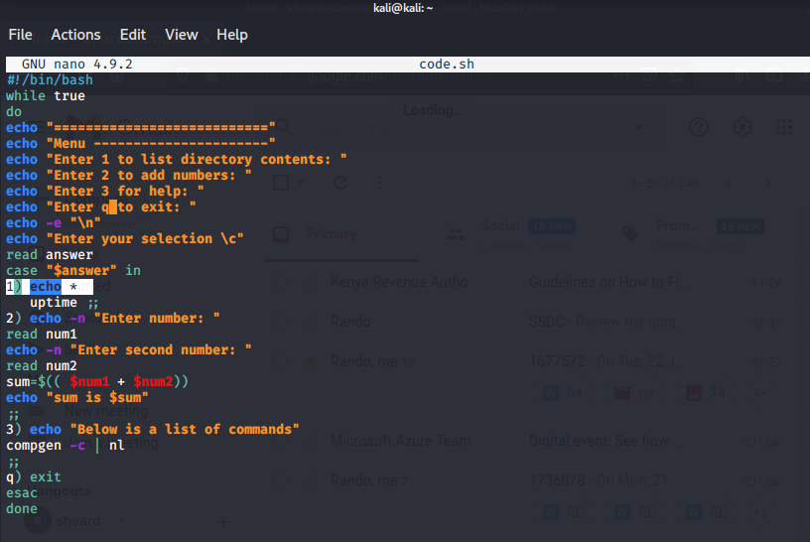

Figure 1

The highlighted piece of code lists the contents of the current directory as shown:

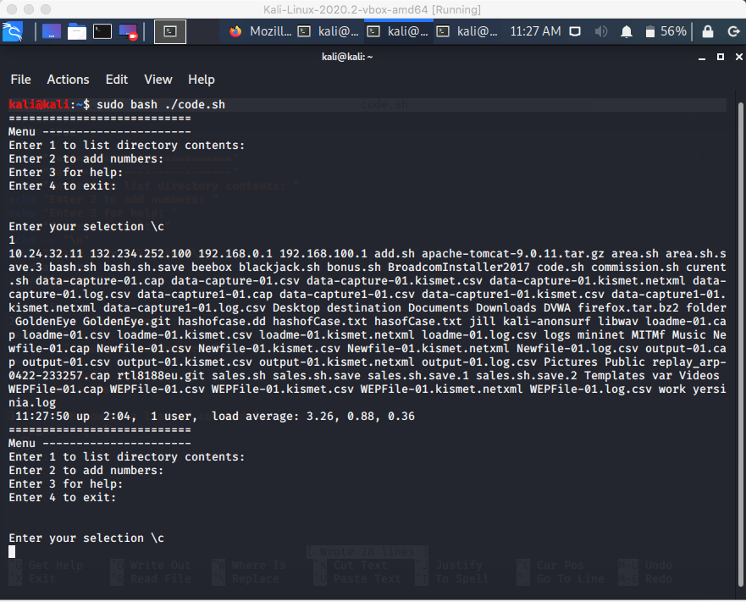

Figure 2

The addition of numbers on the other hand is a simple task performing basic arithmetic on users' supplied values. In this case, the shell script requests users' input to compute the addition as demonstrated from the code and the output respectively.

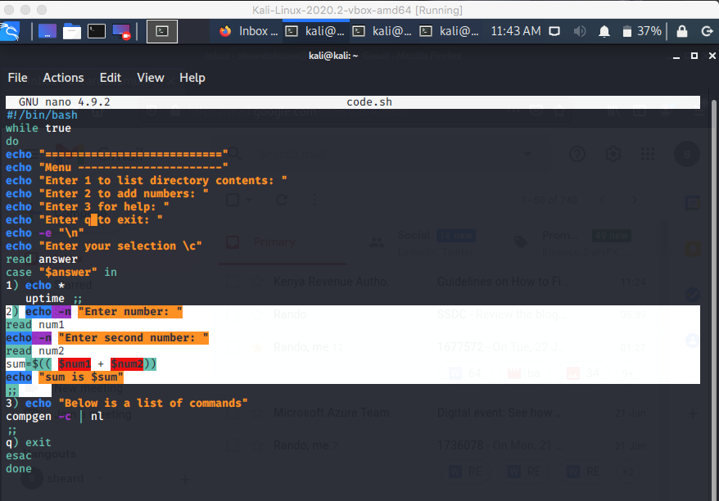

Figure 3: code

The above code yields the following output:

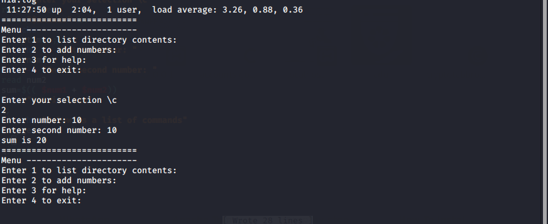

Figure 4

As illustrated, the program requests two user inputs then sums the two to give output according to the summation results.

Displaying the help items in Linux systems is usually facilitated by -help command, this can also be implemented in shell scripts by use of other means as used in this section of the project. In this case, the below segment of the code lists all the help commands that can be used within Linux environments.

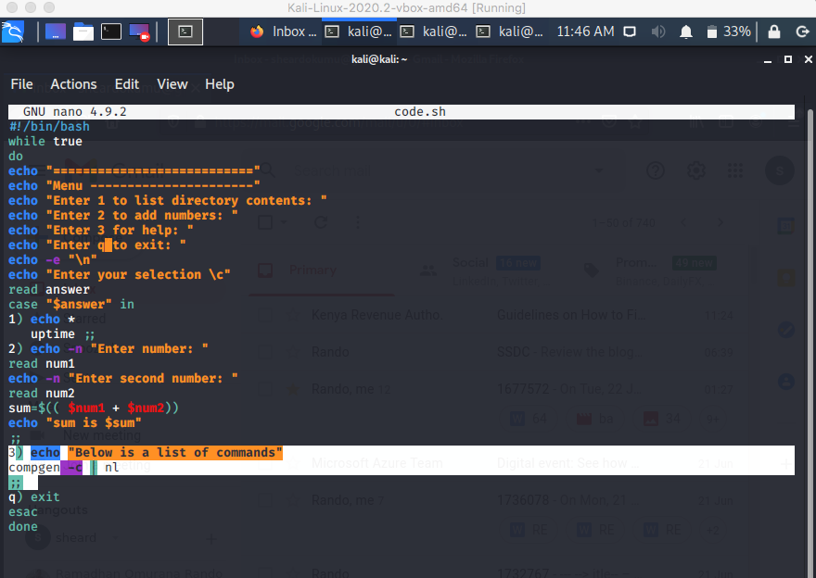

Figure 5

This outputs a long list of commands within the Linux environment as the help items intended.

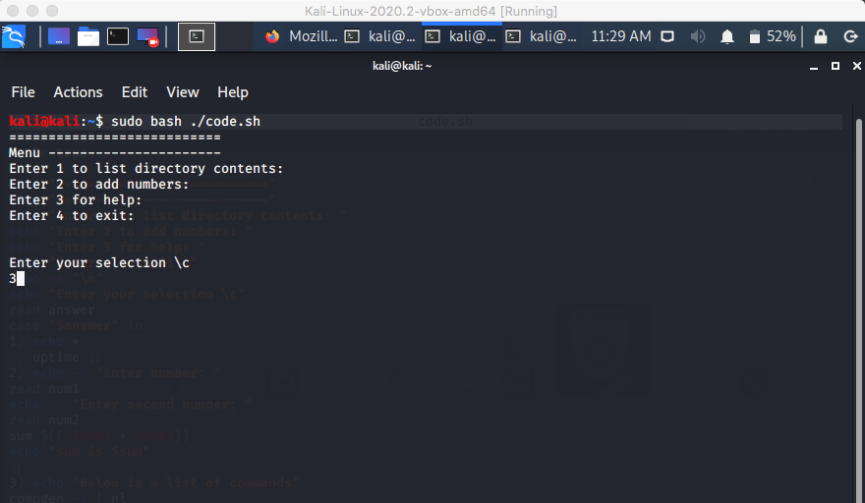

Figure 6

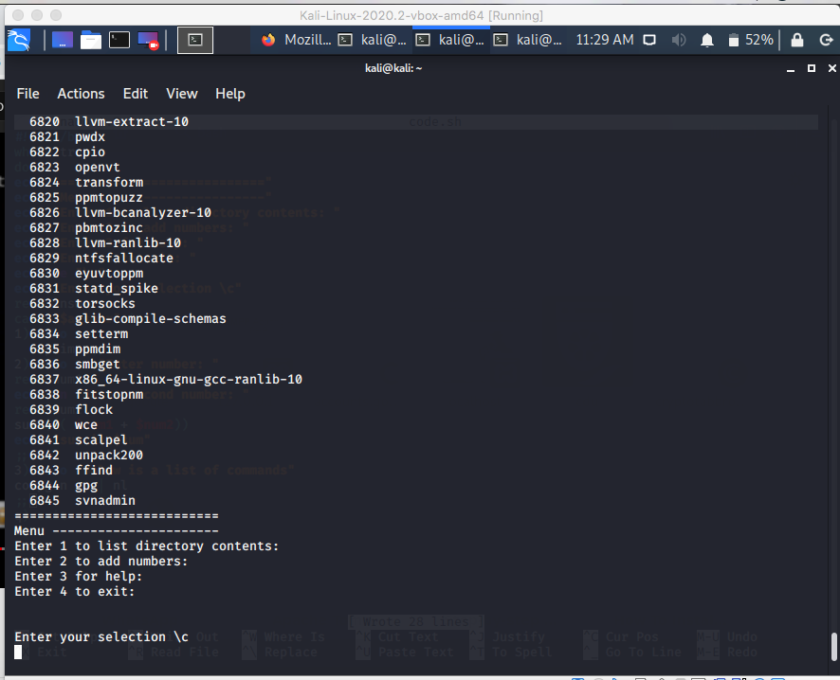

Figure 7

# Vulnerabilities & Security Recommendations

Bash scripts are majorly susceptible to privilege escalation and remote code execution vulnerabilities (O’Leary, 2019.). This leverages the scripts and the entire system to the possibilities of the remote hackers being able to gain access into the system utilizing the OS vulnerabilities. This results in privilege escalation as either vertical or horizontal. As such, the remote attacker can run malicious codes remotely from the gained access through shell script system administration.

Vulnerabilities in this perspective can be disastrous for a system administration case hence necessary to set up security measures against these vulnerabilities. Privilege escalation can be reduced by simply limiting the administrative tasks to only the relevant system users. This can be enhanced by the use of password policies and permissions. Permissions allow users to make changes in the respective directories in the system (Yaswinski, et.al 2019), granting fewer permissions can go a long way in reducing the cases of remote code execution as a result of privilege escalation.

# Reference List

Couto, F.M. and Lamurias, A., 2018. MER: a shell script and annotation server for minimal named entity recognition and linking. *Journal of cheminformatics*, *10*(1), pp.1-10.

Flynt, C., Lakshman, S. and Tushar, S., 2017. *Linux Shell Scripting Cookbook*. Packt Publishing Ltd.

O’Leary, M., 2019. Privilege Escalation in Linux. In *Cyber Operations* (pp. 419-453). Apress, Berkeley, CA.

Yaswinski, M.R., Chowdhury, M.M. and Jochen, M., 2019, May. Linux Security: A Survey. In *2019 IEEE International Conference on Electro Information Technology (EIT)* (pp. 357-362). IEEE.